**FONT APPLICATION**

**FORM DESIGN**

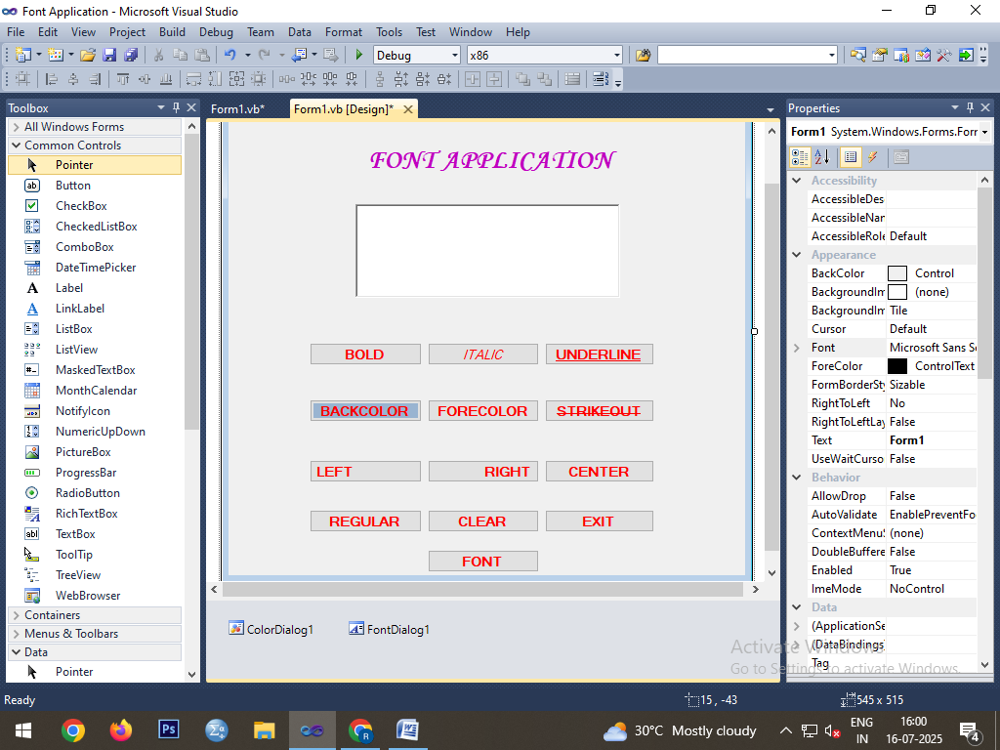

**CODING**

Public Class Form1

Private Sub Button1_Click(ByVal sender As System.Object, ByVal e As System.EventArgs) Handles Button1.Click

RichTextBox1.SelectionFont = New Font(RichTextBox1.SelectionFont, FontStyle.Bold)

End Sub

Private Sub Button2_Click(ByVal sender As System.Object, ByVal e As System.EventArgs) Handles Button2.Click

RichTextBox1.SelectionFont = New Font(RichTextBox1.SelectionFont, FontStyle.Italic)

End Sub

Private Sub Button3_Click(ByVal sender As System.Object, ByVal e As System.EventArgs) Handles Button3.Click

RichTextBox1.SelectionFont = New Font(RichTextBox1.SelectionFont, FontStyle.Underline)

End Sub

Private Sub Button6_Click(ByVal sender As System.Object, ByVal e As System.EventArgs) Handles Button6.Click

RichTextBox1.SelectionFont = New Font(RichTextBox1.SelectionFont, FontStyle.Strikeout)

End Sub

Private Sub Button12_Click(ByVal sender As System.Object, ByVal e As System.EventArgs) Handles Button12.Click

RichTextBox1.SelectionFont = New Font(RichTextBox1.SelectionFont, FontStyle.Regular)

End Sub

Private Sub Button4_Click(ByVal sender As System.Object, ByVal e As System.EventArgs) Handles Button4.Click

ColorDialog1.ShowDialog()

RichTextBox1.BackColor = ColorDialog1.Color

End Sub

Private Sub Button5_Click(ByVal sender As System.Object, ByVal e As System.EventArgs) Handles Button5.Click

ColorDialog1.ShowDialog()

RichTextBox1.ForeColor = ColorDialog1.Color

End Sub

Private Sub Button7_Click(ByVal sender As System.Object, ByVal e As System.EventArgs) Handles Button7.Click

RichTextBox1.SelectionAlignment = HorizontalAlignment.Left

End Sub

Private Sub Button8_Click(ByVal sender As System.Object, ByVal e As System.EventArgs) Handles Button8.Click

RichTextBox1.SelectionAlignment = HorizontalAlignment.Right

End Sub

Private Sub Button9_Click(ByVal sender As System.Object, ByVal e As System.EventArgs) Handles Button9.Click

RichTextBox1.SelectionAlignment = HorizontalAlignment.Center

End Sub

Private Sub Button10_Click(ByVal sender As System.Object, ByVal e As System.EventArgs) Handles Button10.Click

RichTextBox1.Clear()

End Sub

Private Sub Button11_Click(ByVal sender As System.Object, ByVal e As System.EventArgs) Handles Button11.Click

End

End Sub

Private Sub Button13_Click(ByVal sender As System.Object, ByVal e As System.EventArgs) Handles Button13.Click

FontDialog1.ShowDialog()

RichTextBox1.Font = FontDialog1.Font

End Sub

End Class

**OUTPUT**

